**EX. No. 1 – DDL Commands using CREATE, ALTER, TRUNCATE, and DROP**

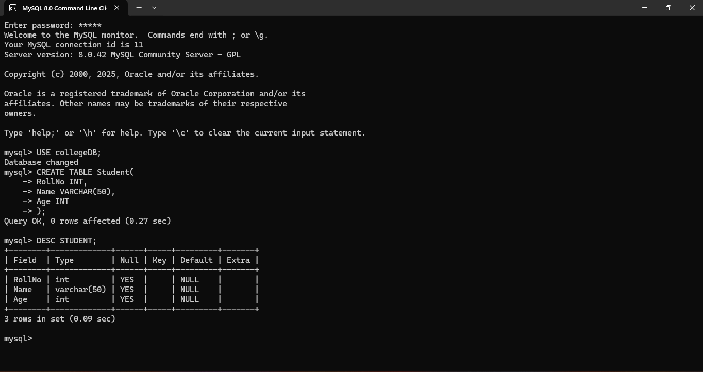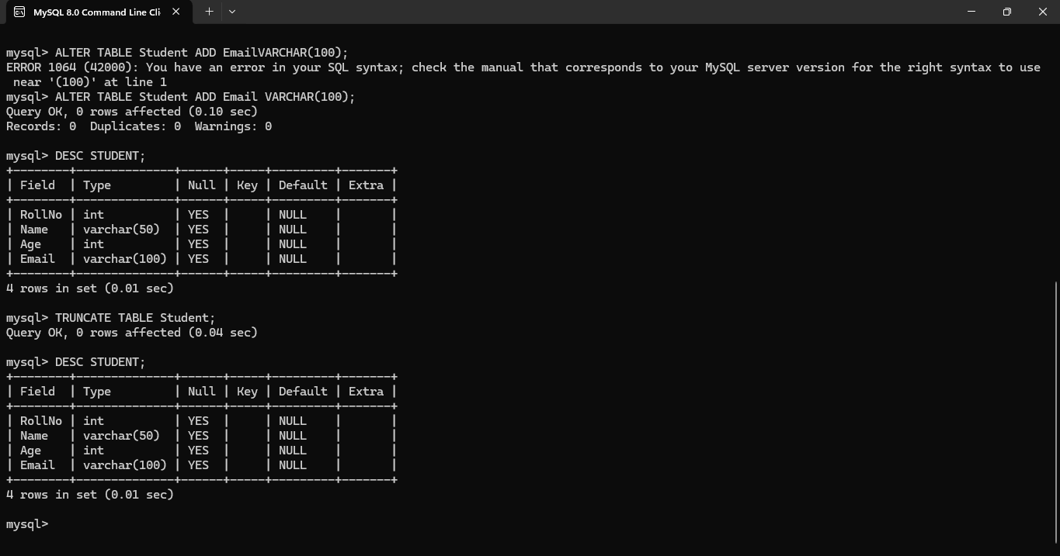

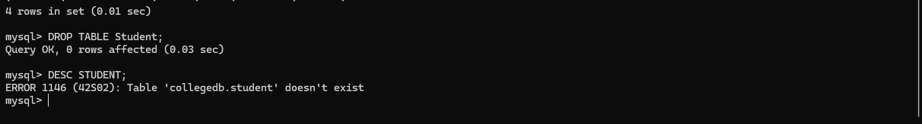

**EX. No. 2 – DDL Commands with Constraints**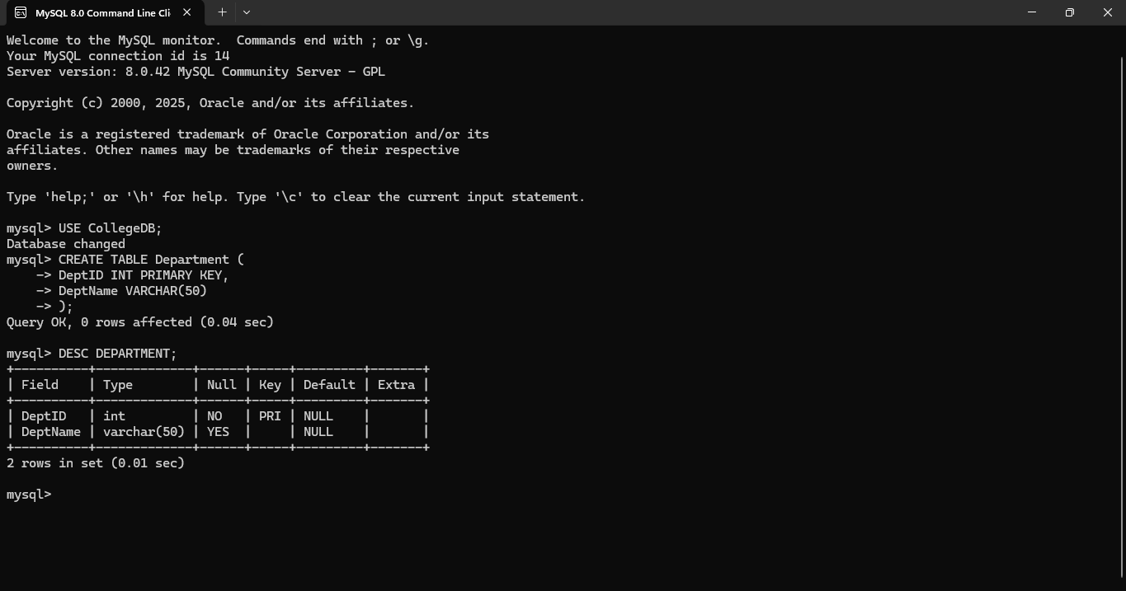

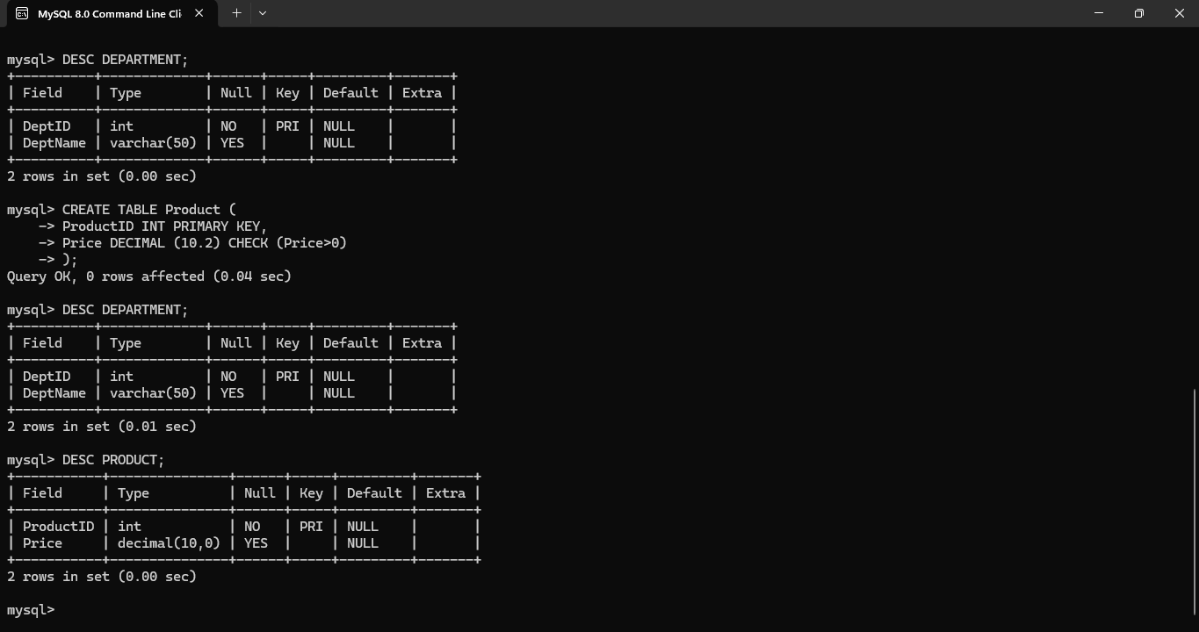

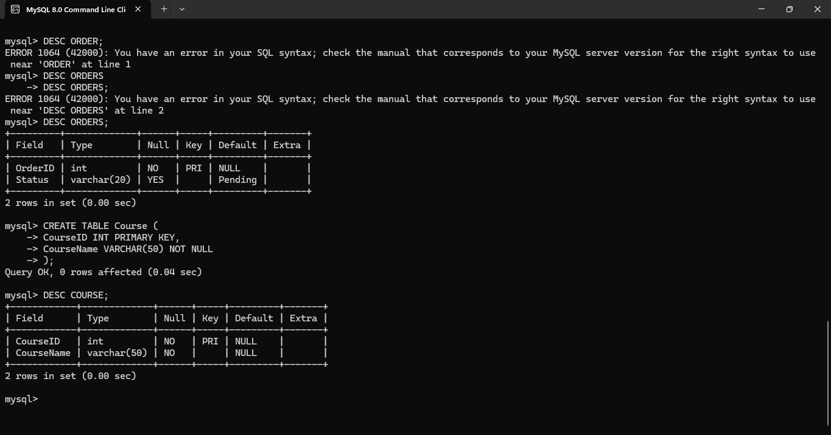

**EX 3 DML Commands using INSERT and SELECT**

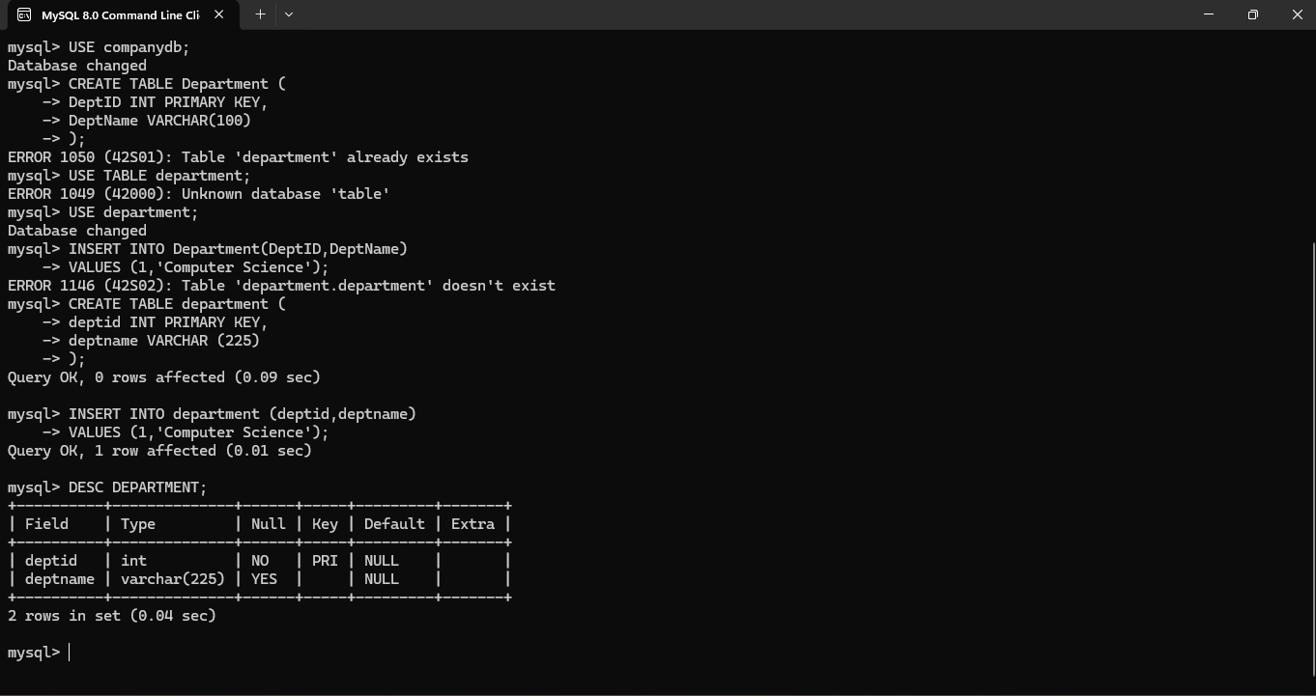

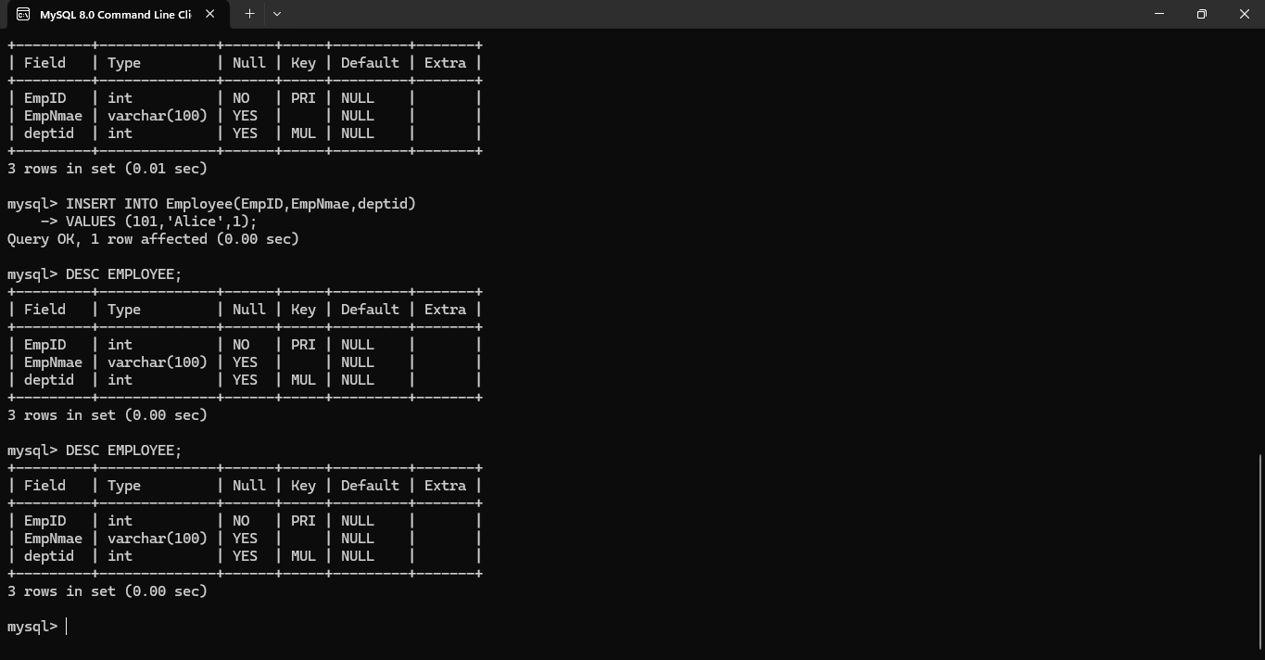

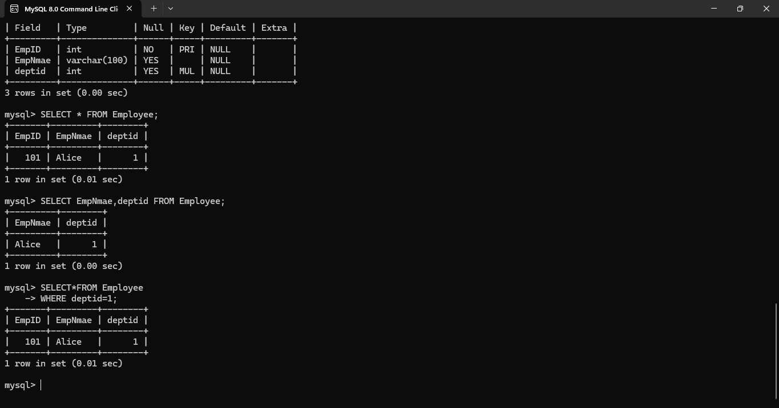

**EX. No. 4 – DML Commands using UPDATE and DELETE**

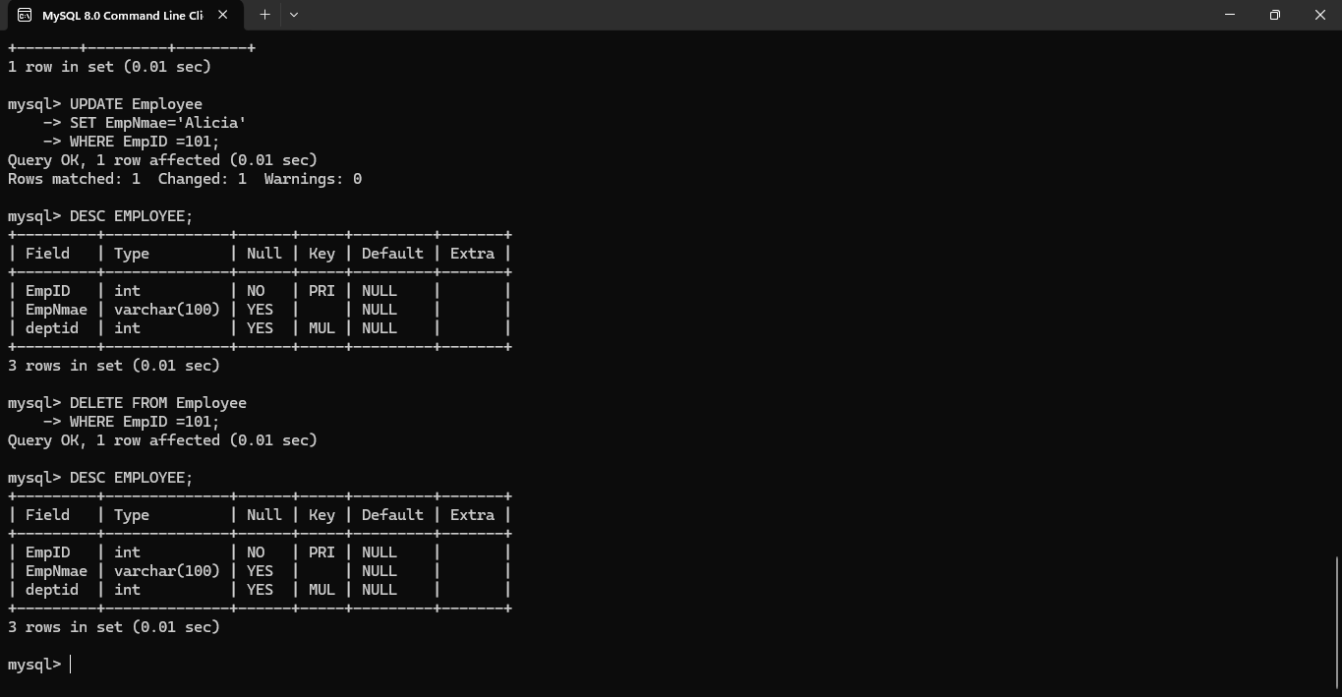

**EX. No. 5 – TCL Commands: COMMIT, SAVEPOINT, ROLLBACK**

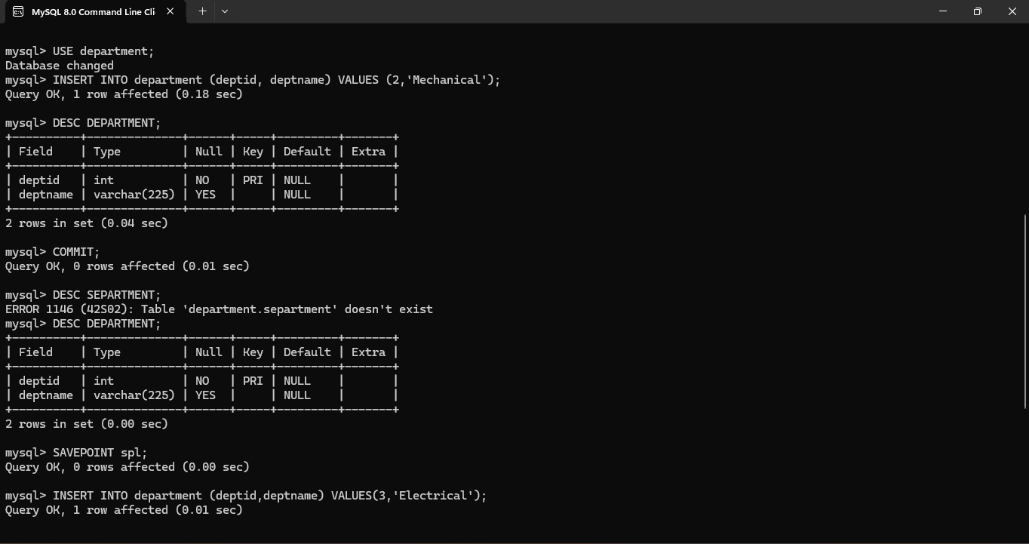

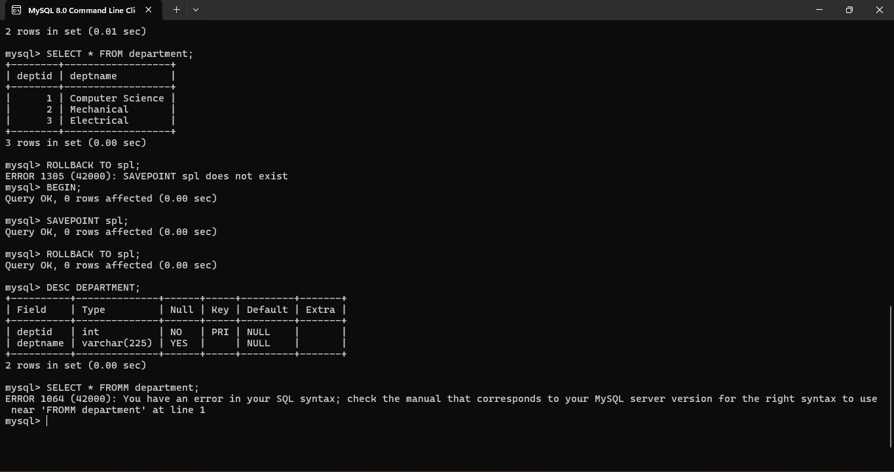

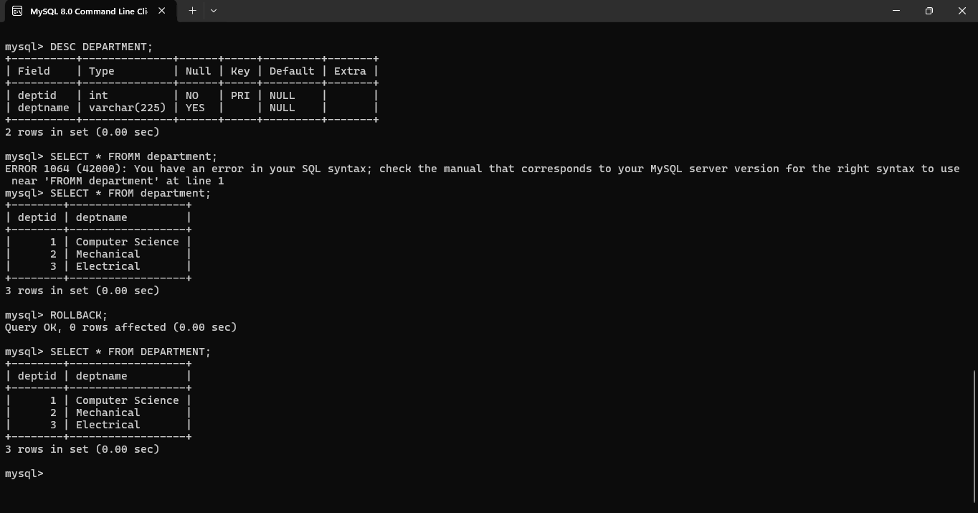

**EX. No. 6 – DCL Commands: GRANT and REVOKE**

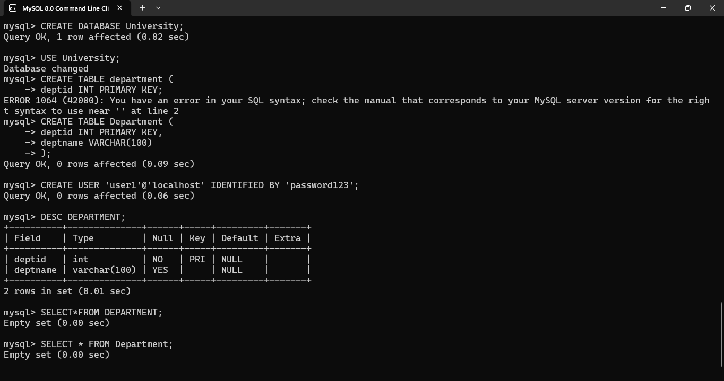

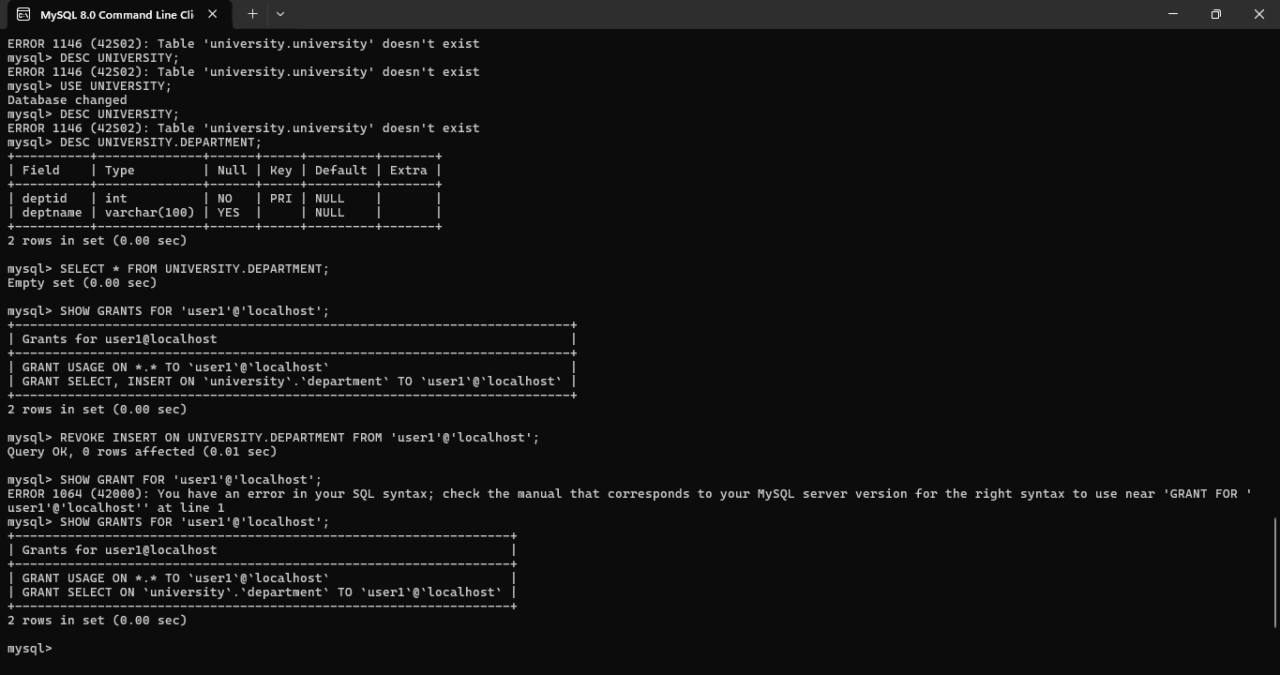

**EX. No. 7 – SELECT with Various Clauses: WHERE, Pattern Matching**

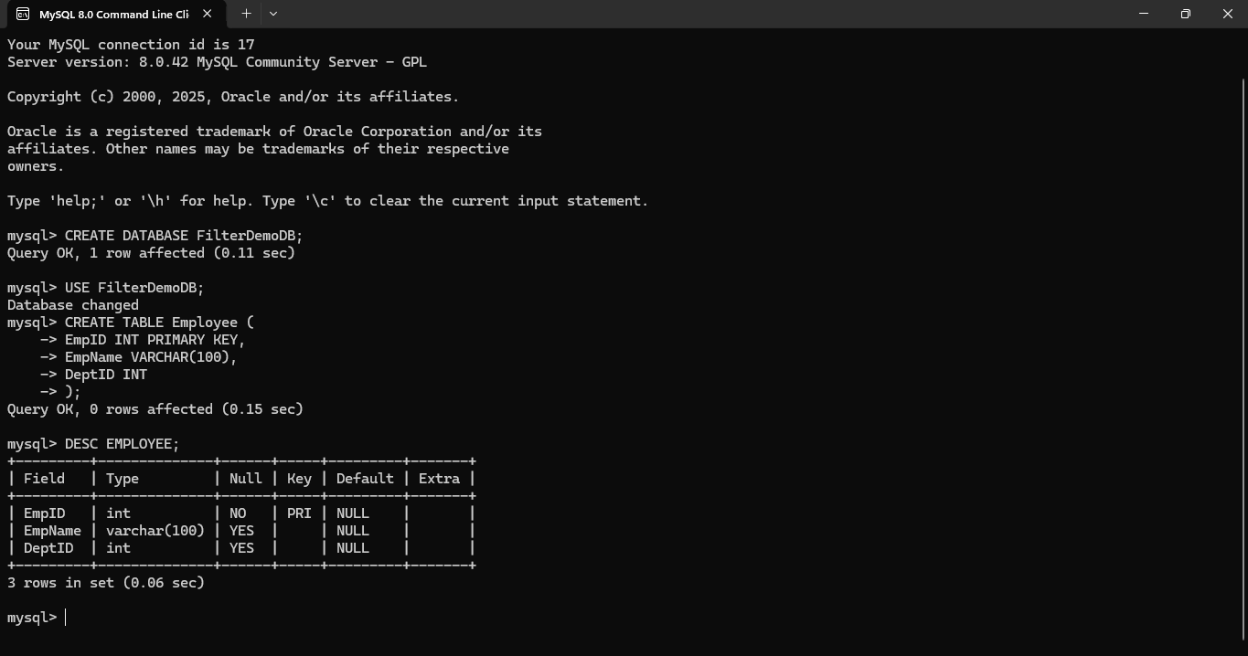

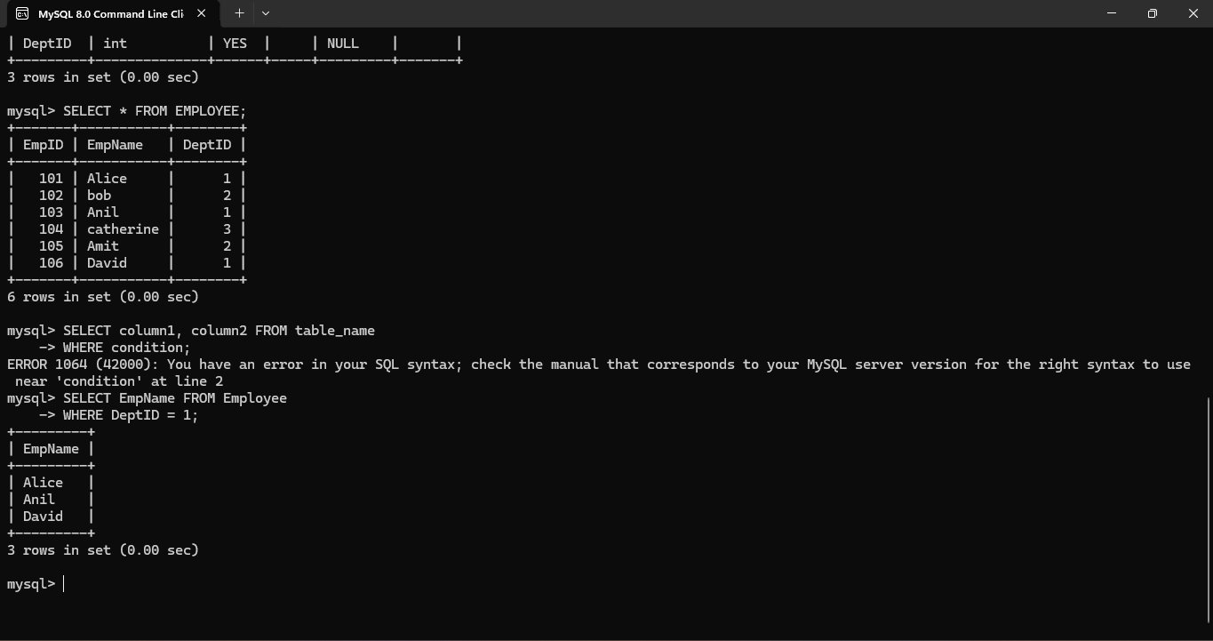

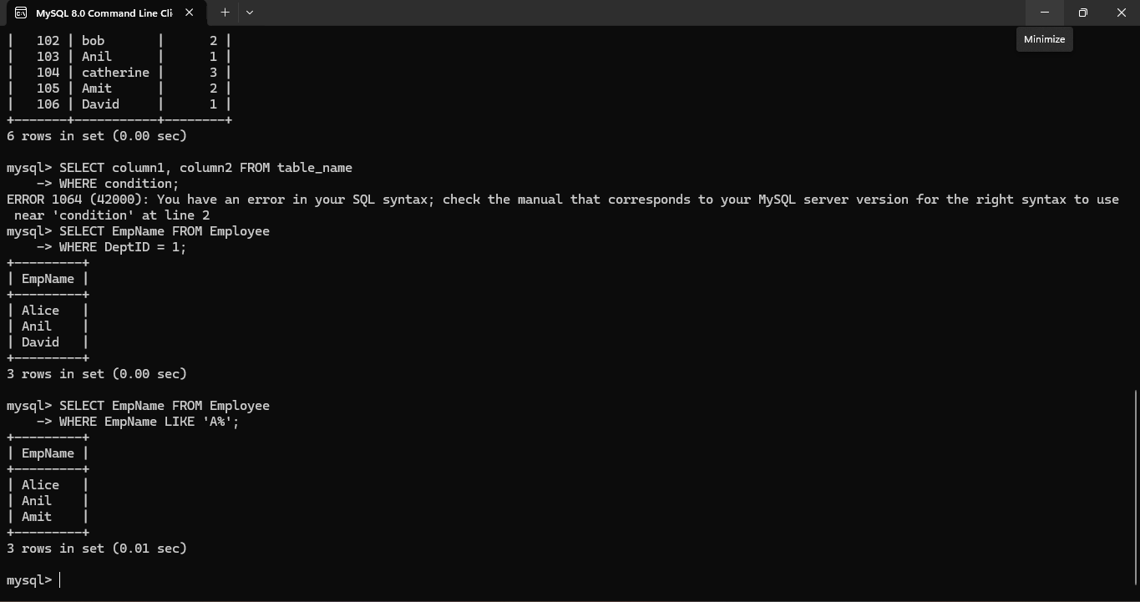

**EX 8 SELECT with Various Clauses: BETWEEN, IN, Aggregate Function**

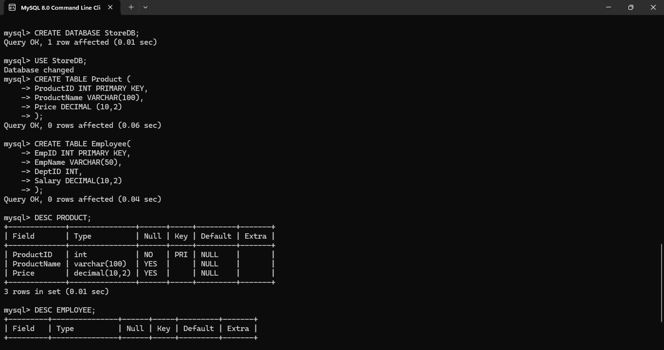

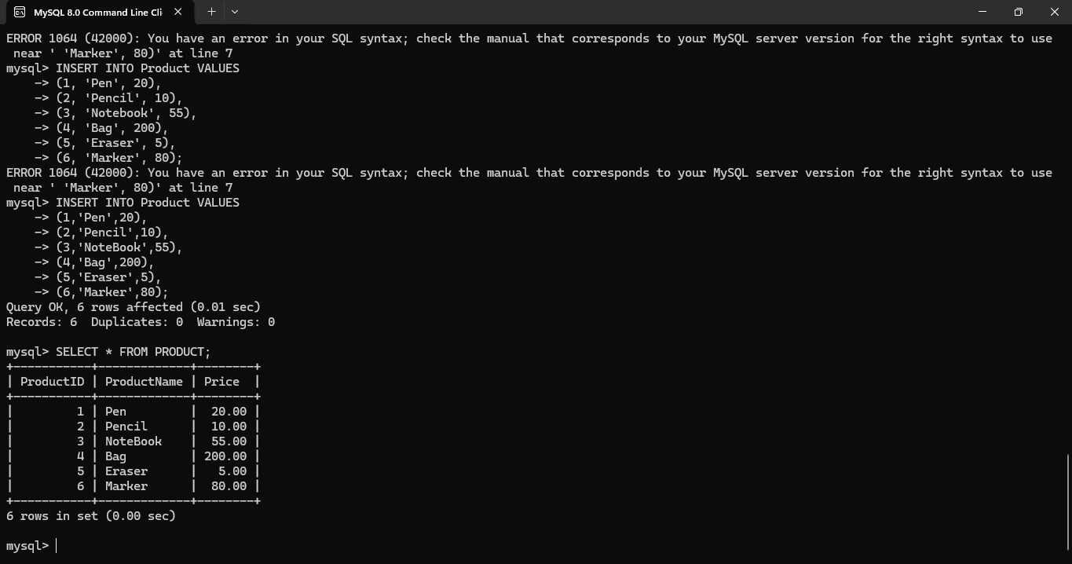

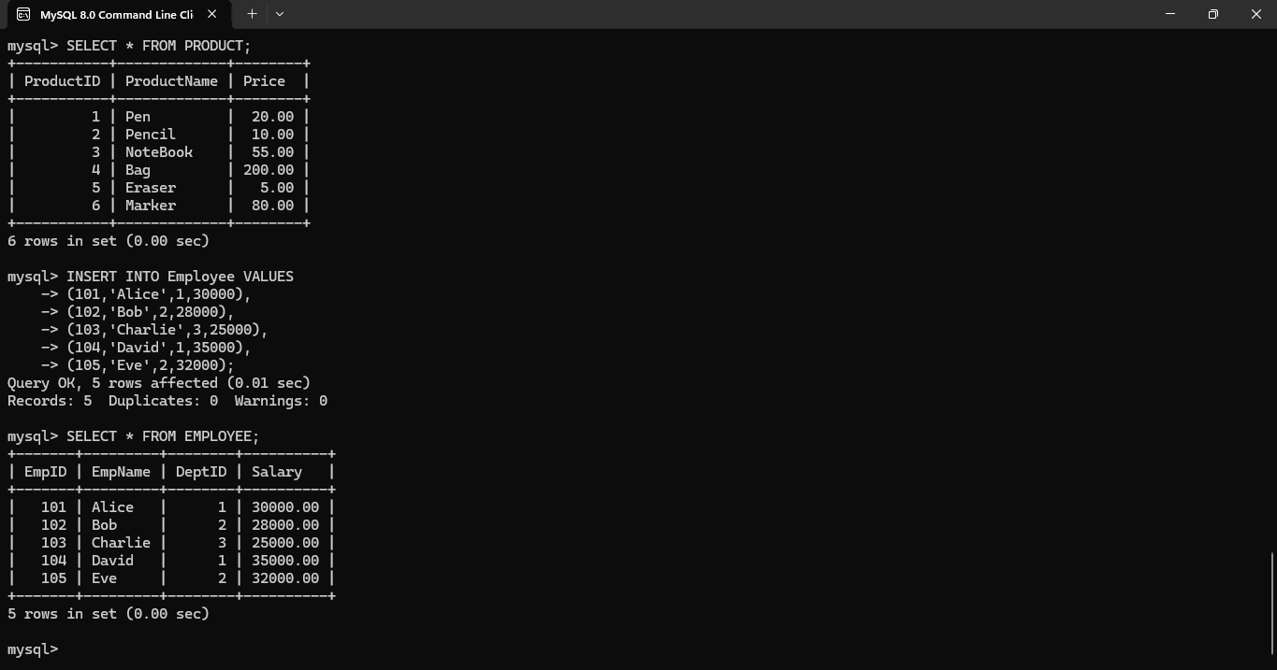

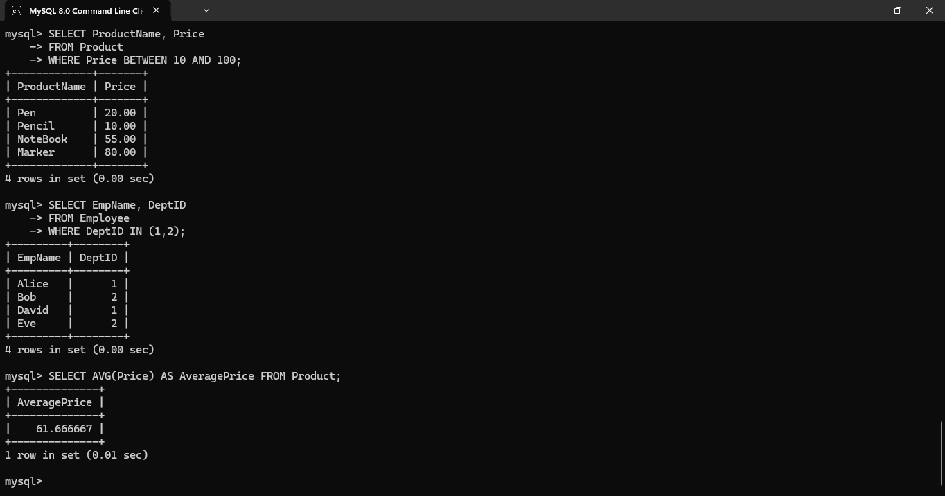

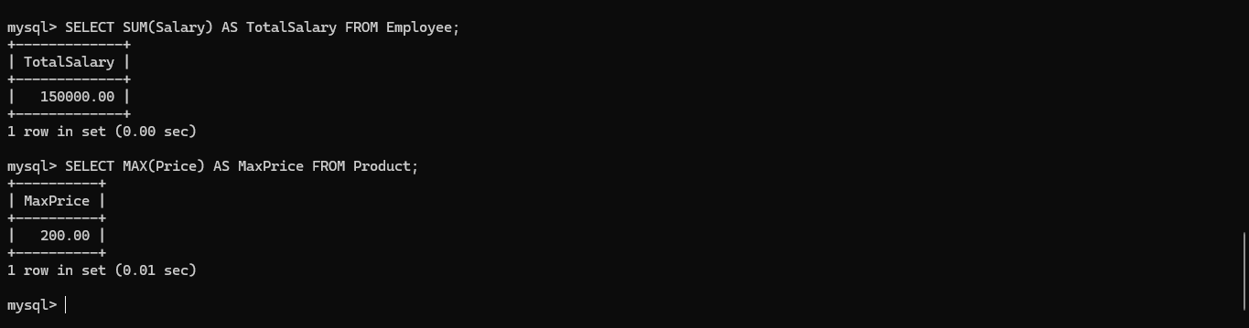

**EX. No. 9 – SELECT with Various Clauses: GROUP BY, HAVING, ORDER BY**

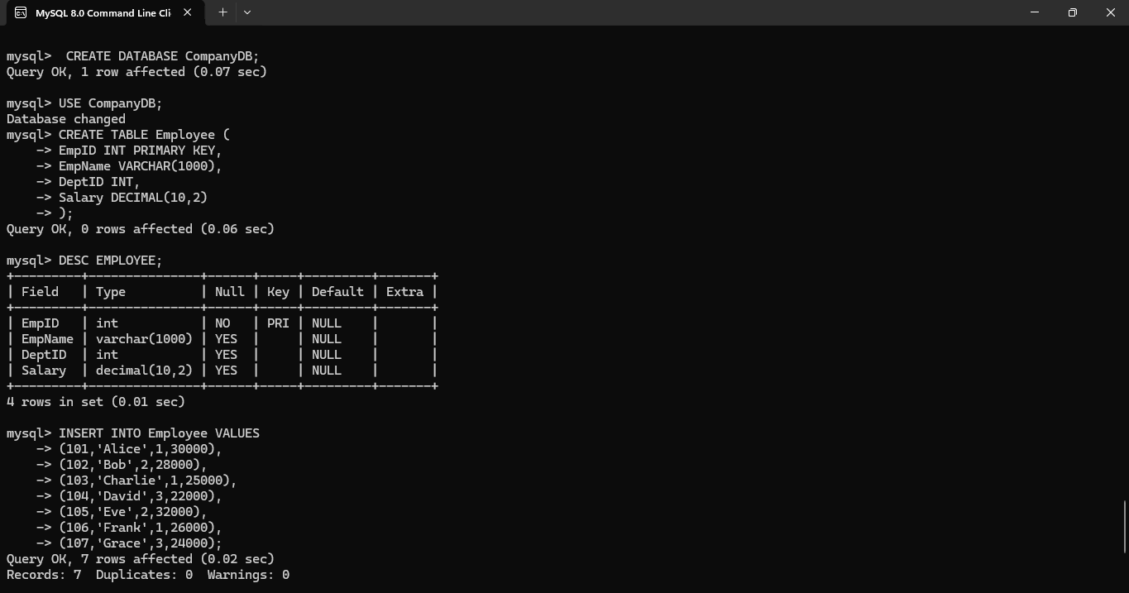

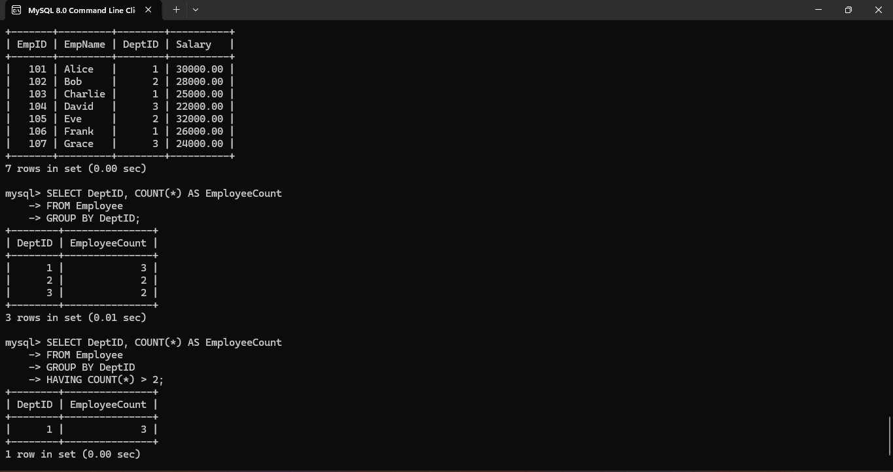

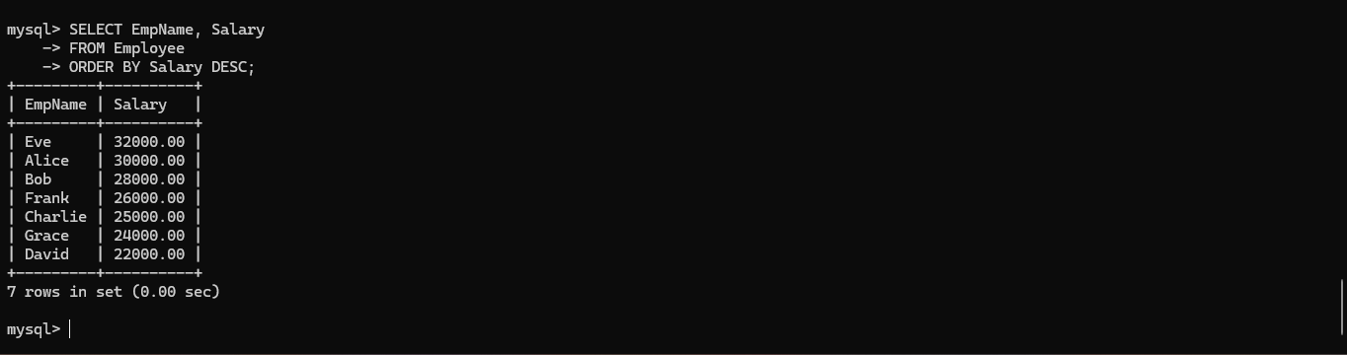**EX. No. 10 – Query with Subquery and Correlated Query**

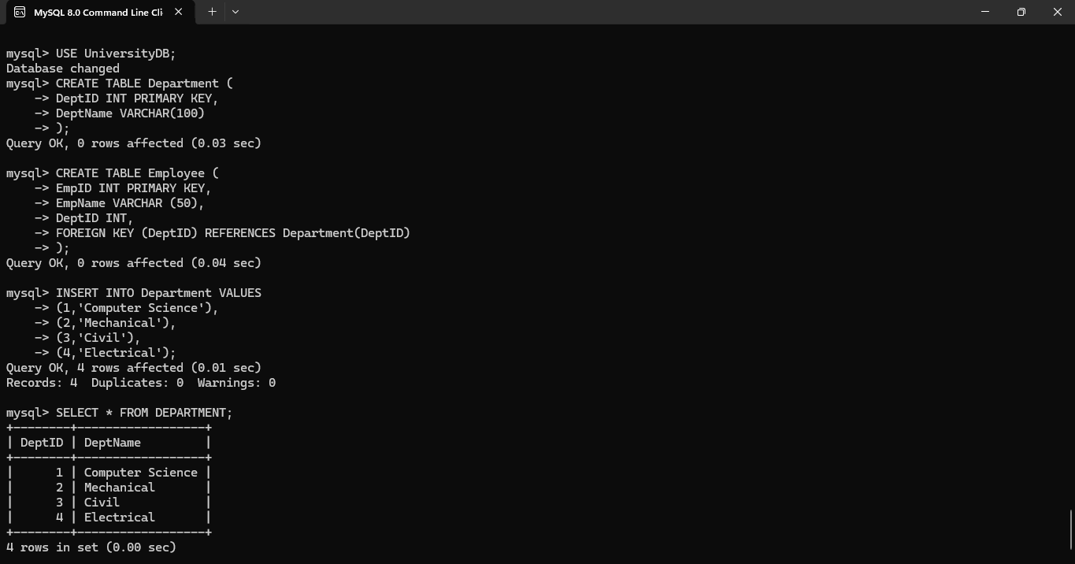

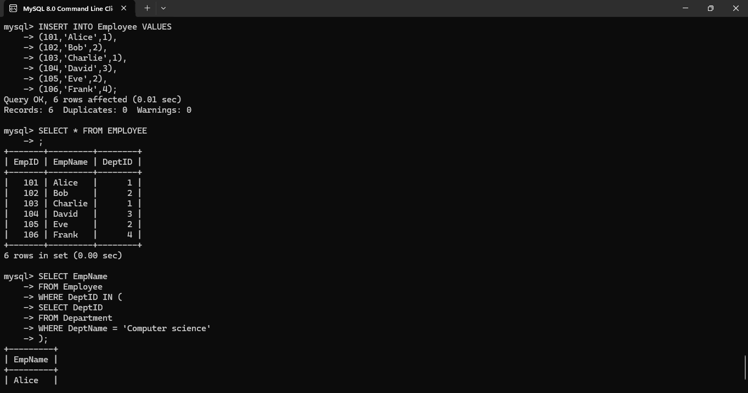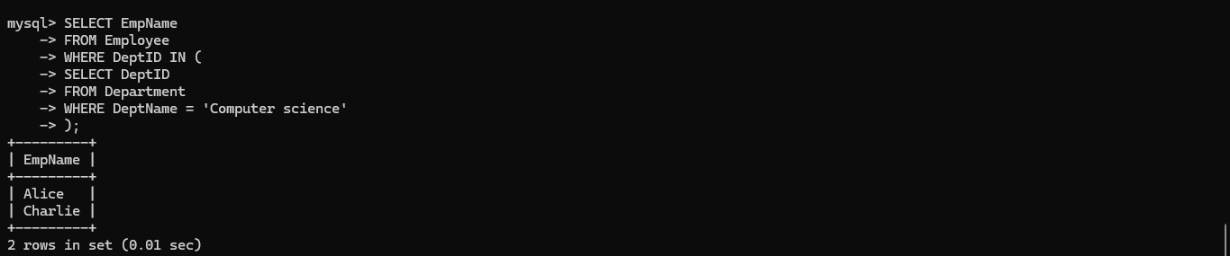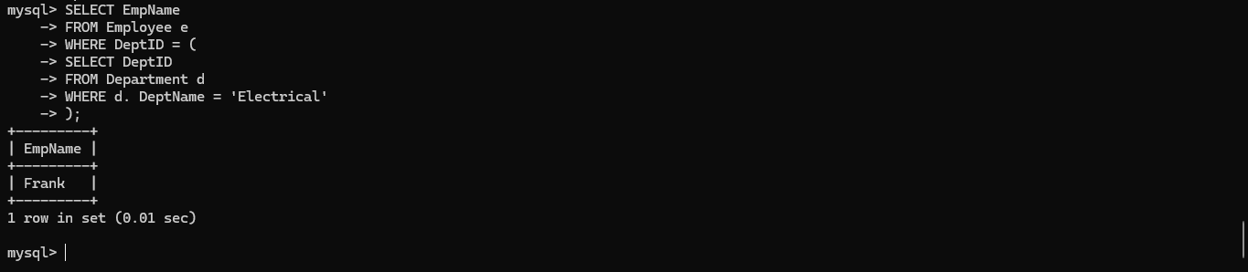

**EX. No. 11 – Query with Joins: EquiJoin, InnerJoin, OuterJoin**

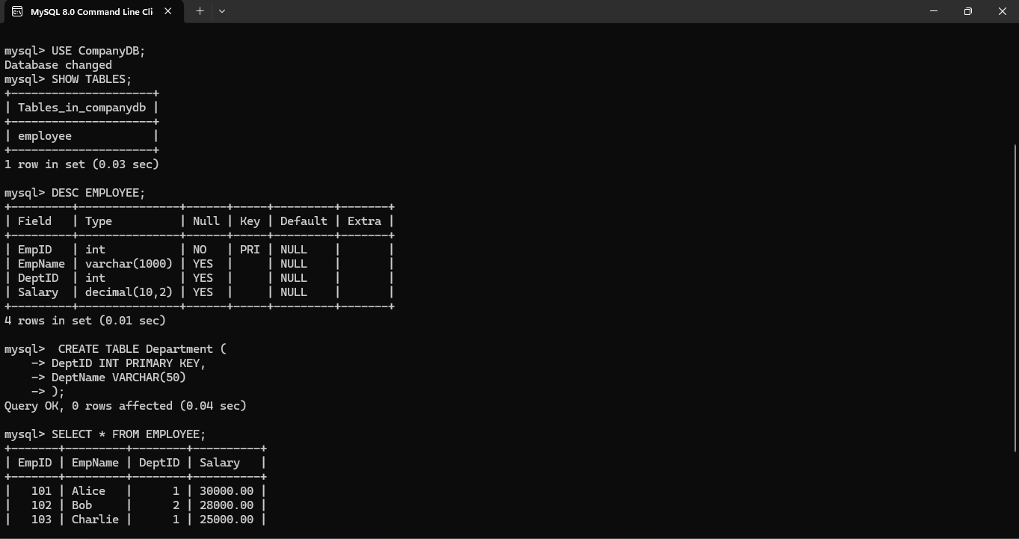

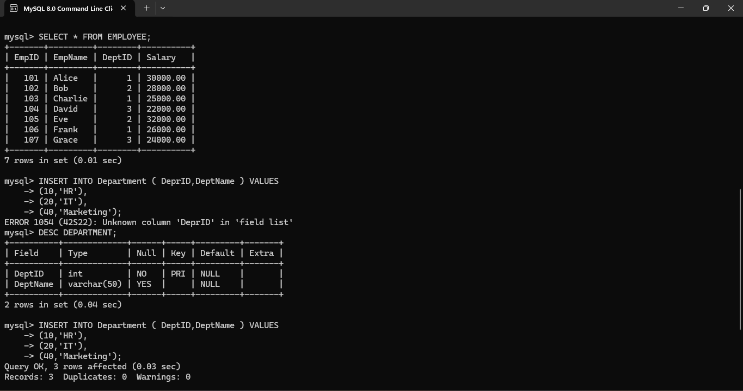

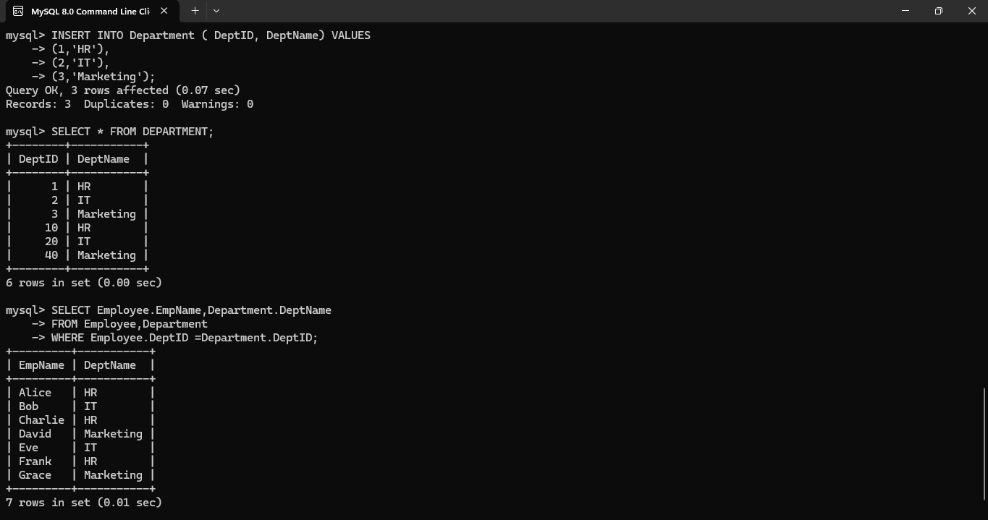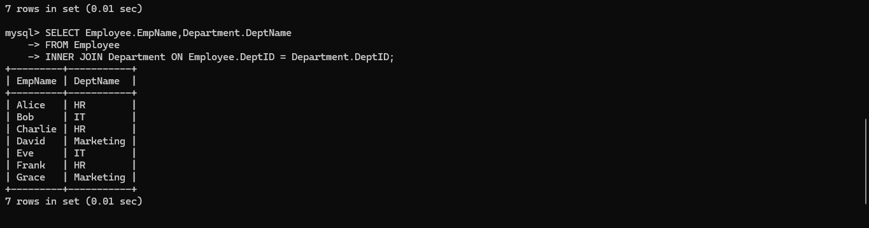

**EX. No. 12 – Query with VIEW and INDEX**

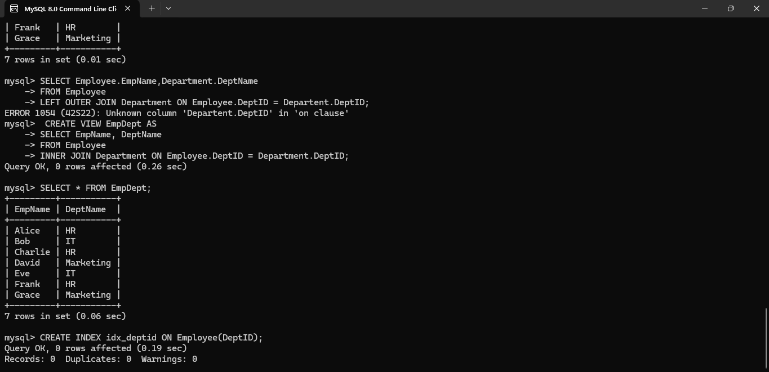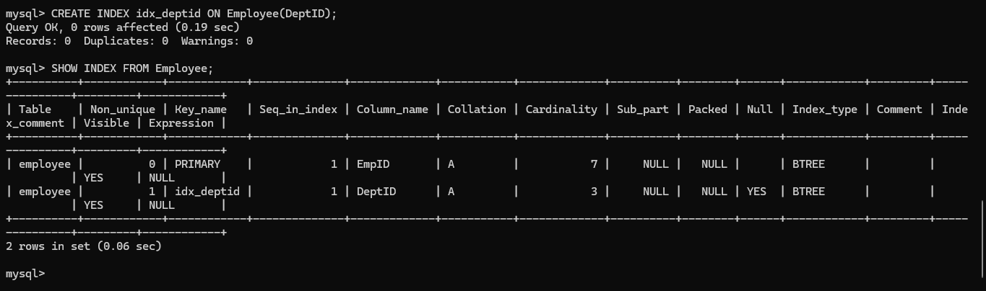

**EX. No. 13 – Query with AUTO_INCREMENT SEQUENCES** 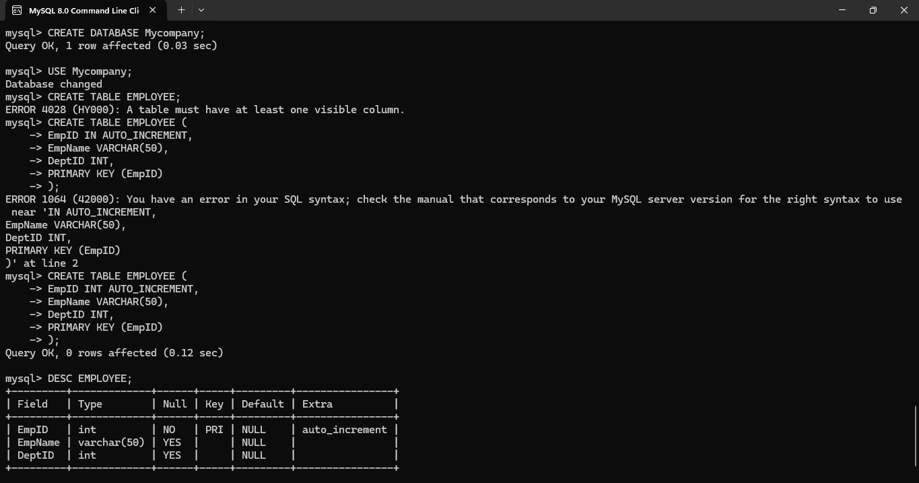 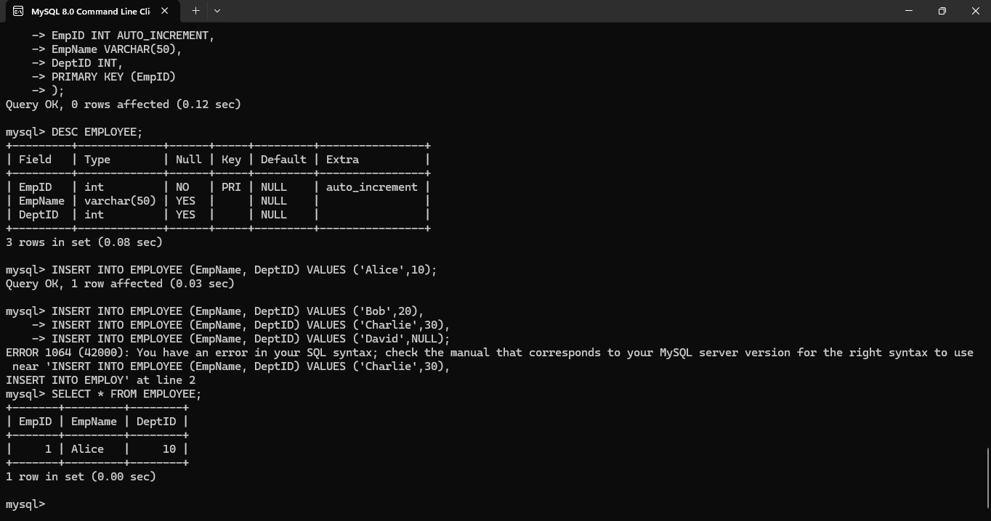

**EX. No. 14 – Simple Programming using REPEAT and WHILE**

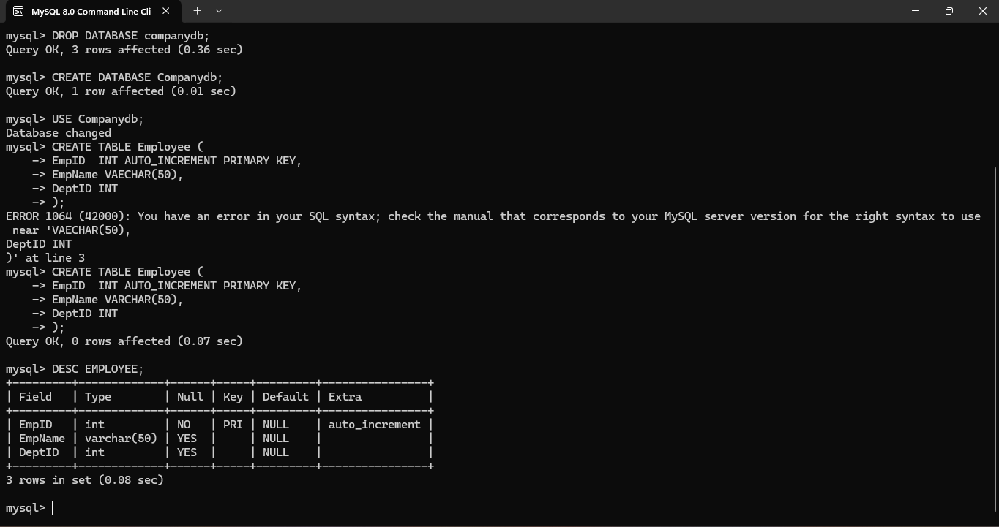

**EX. No. 15 – Simple Programming using CASE and LOOP**

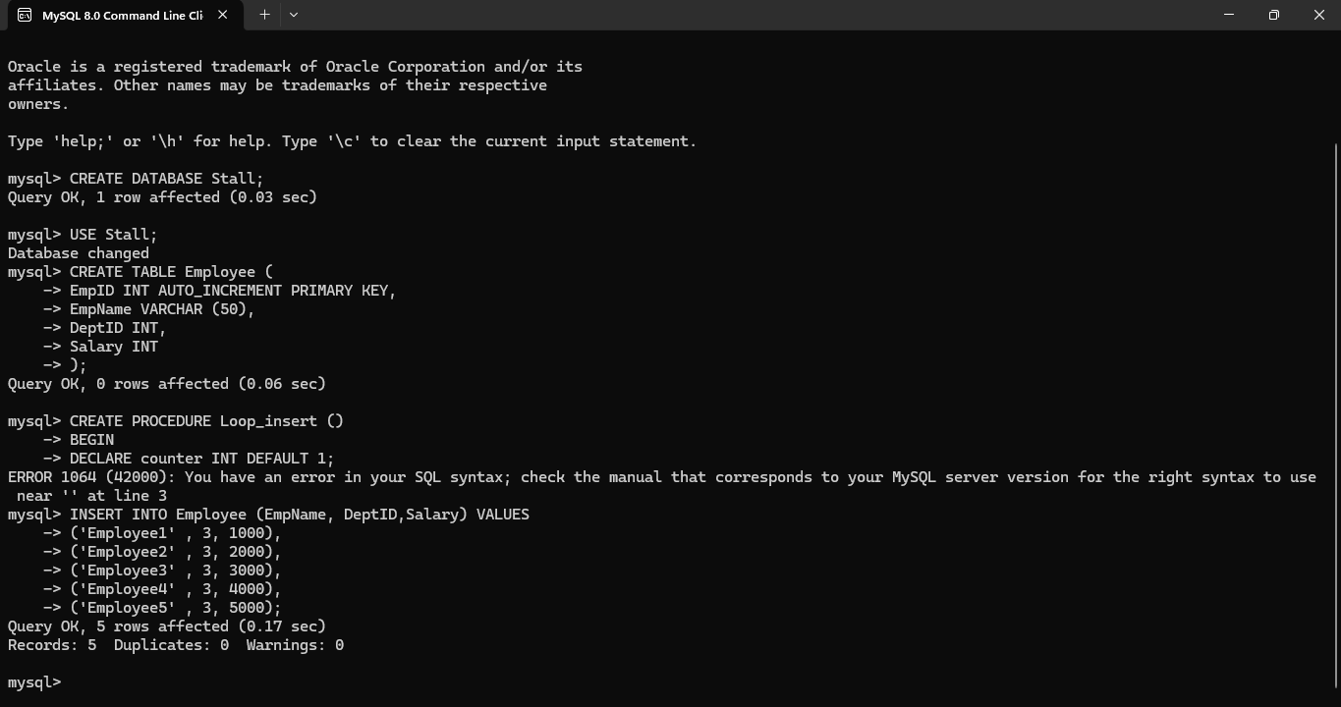

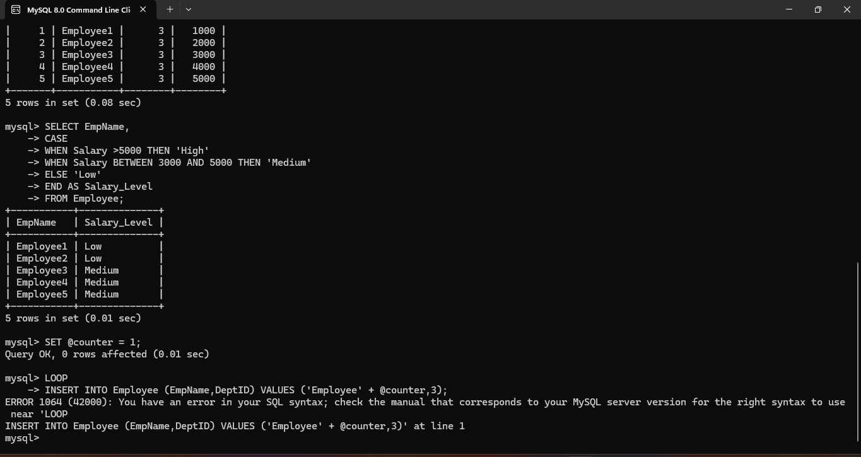

**EX. No. 16 – High-Level Programming Extensions – Procedures**

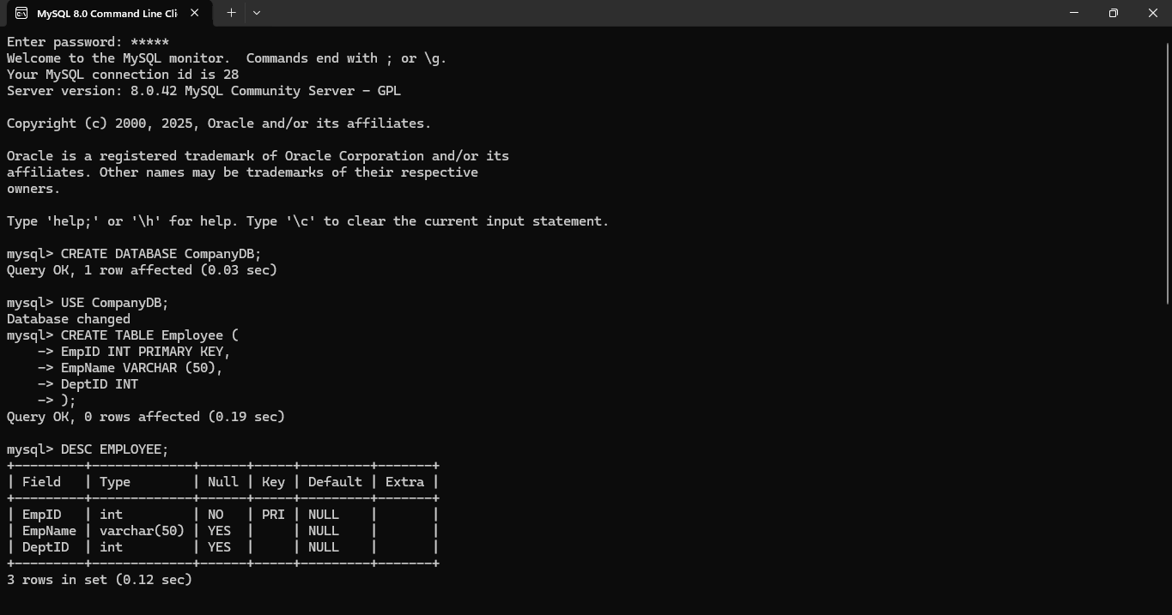

**EX. No. 17 – High-Level Programming Extensions – Function**

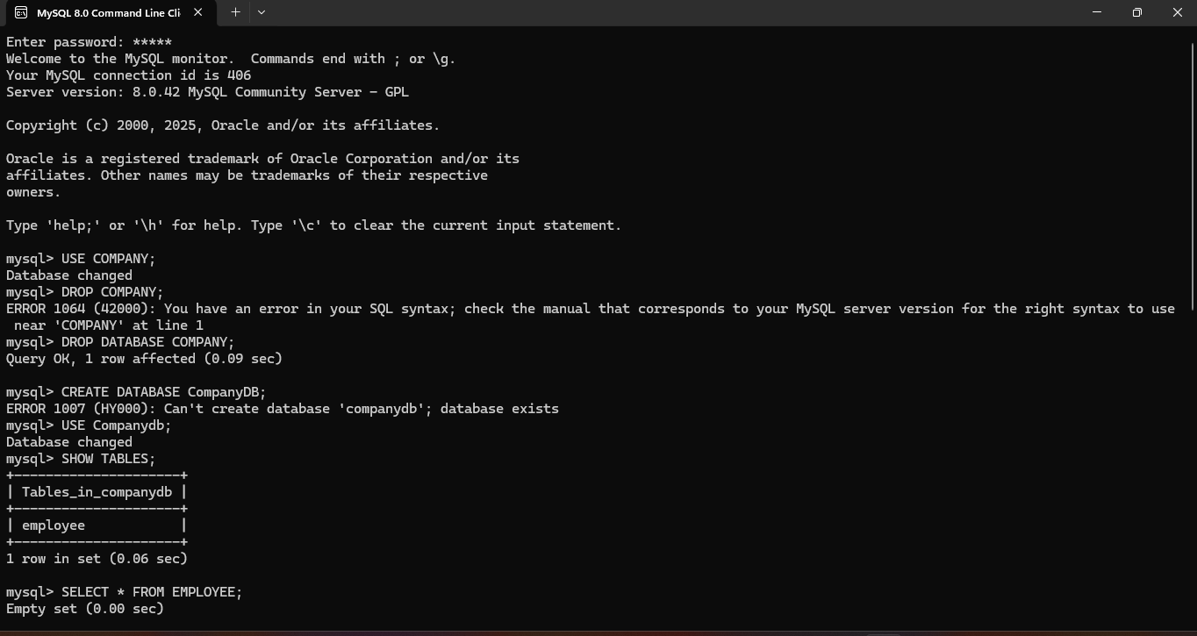

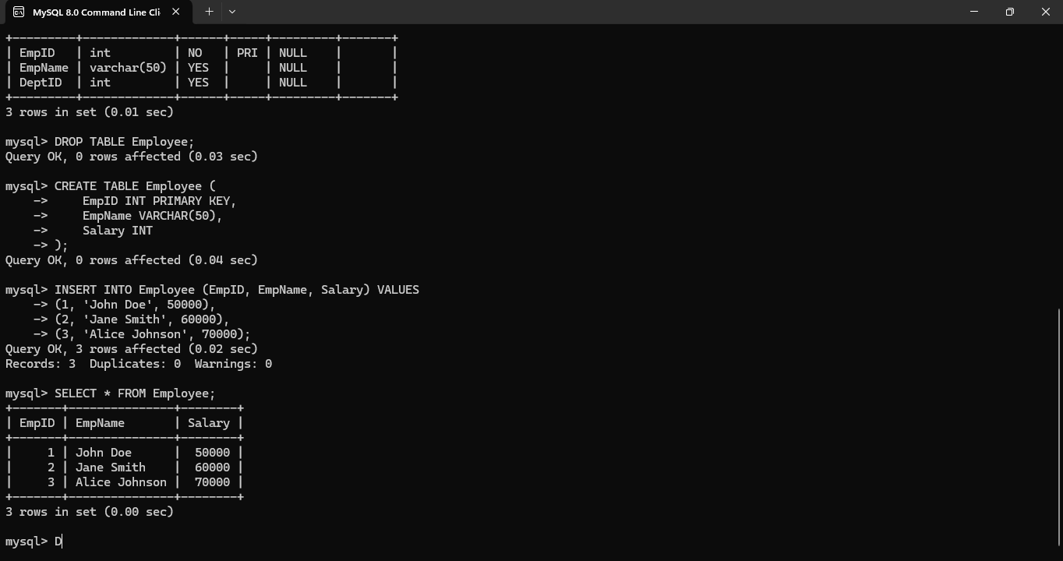

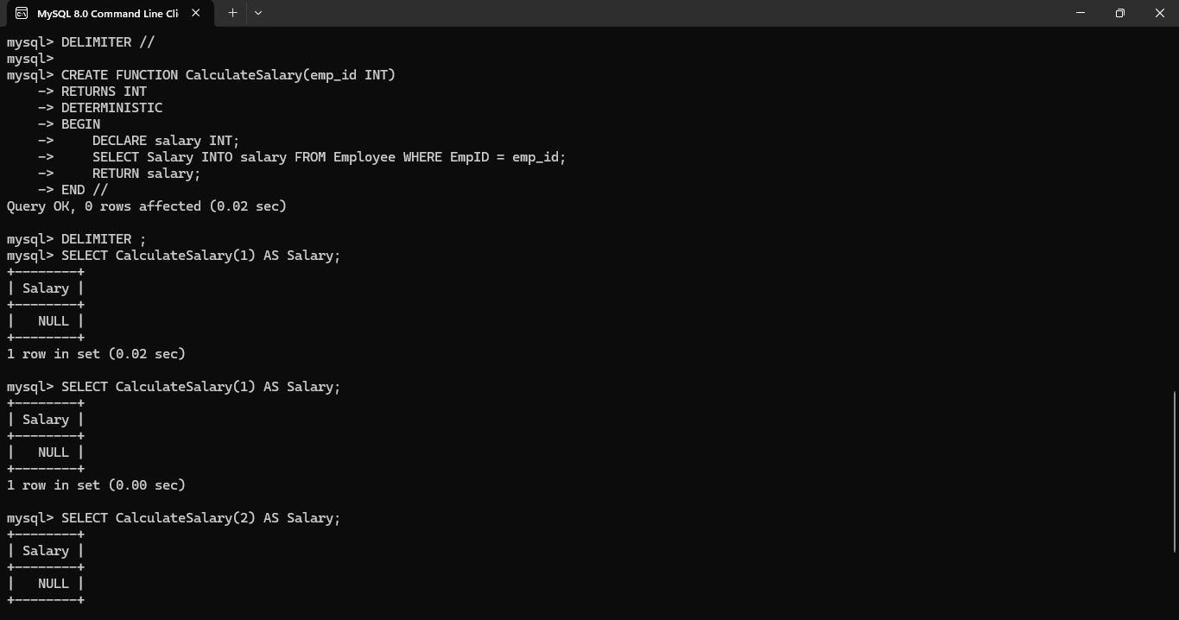

**EX. No. 18 – High-Level Programming Extensions – Cursors**

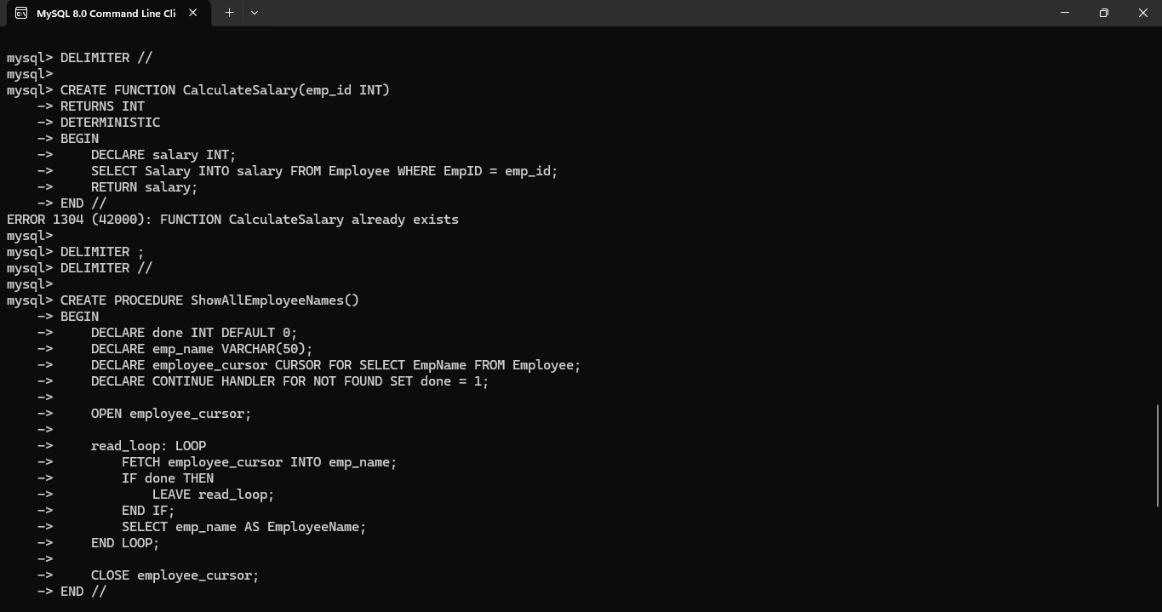

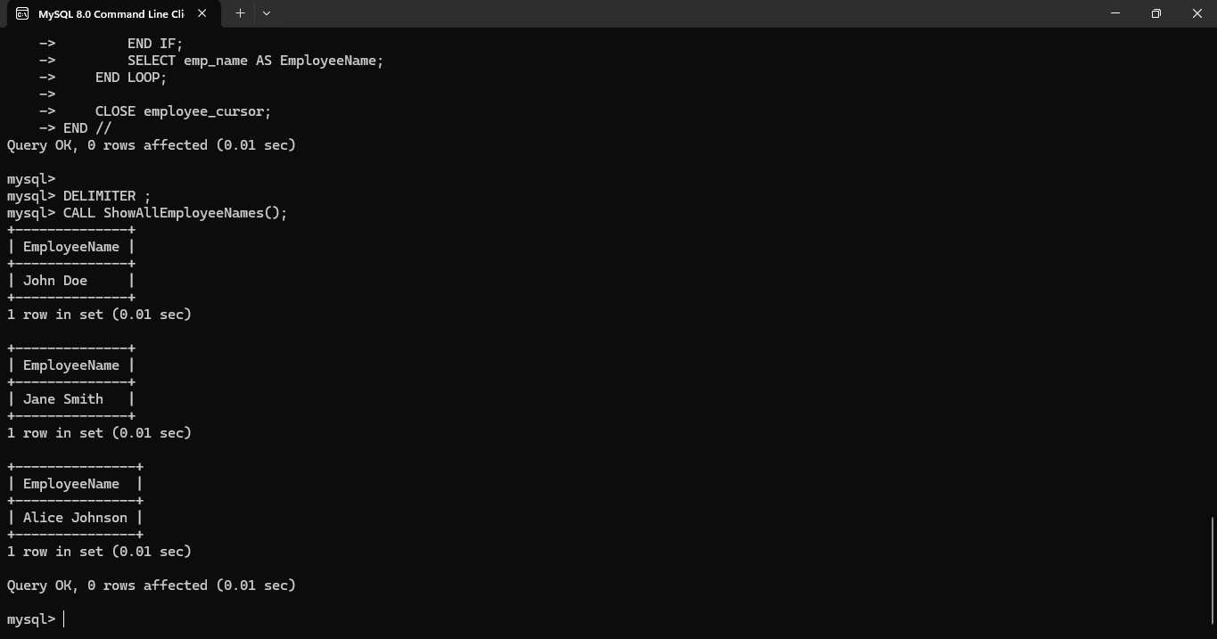

**EX. No. 19 – High-Level Programming Extensions – Triggers**

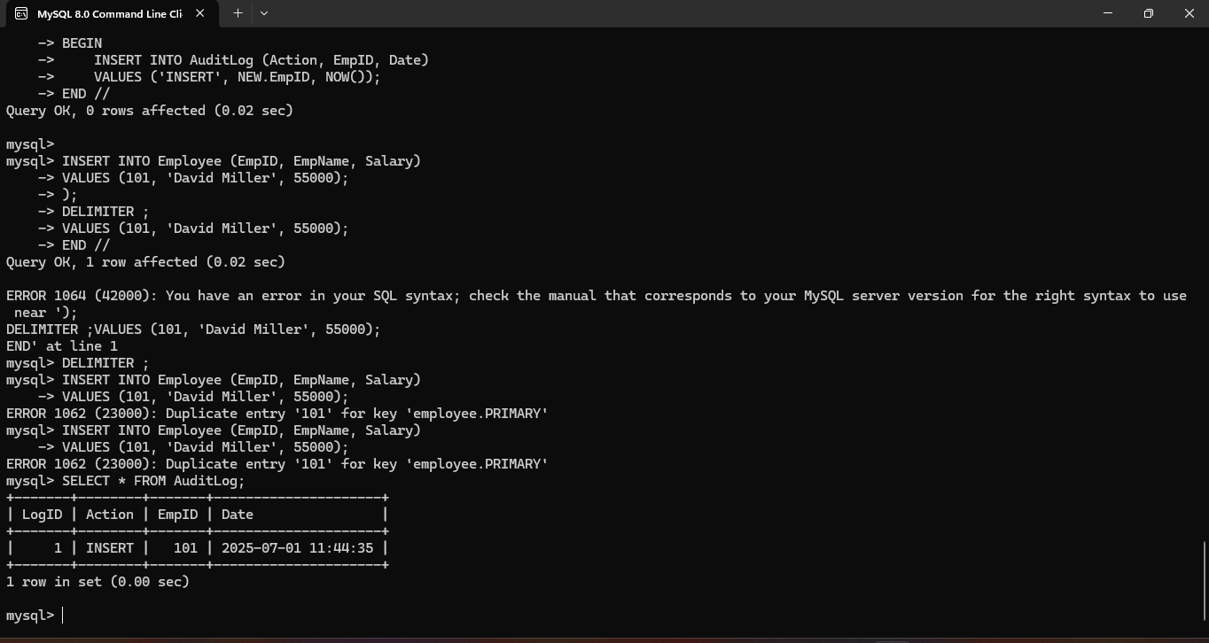

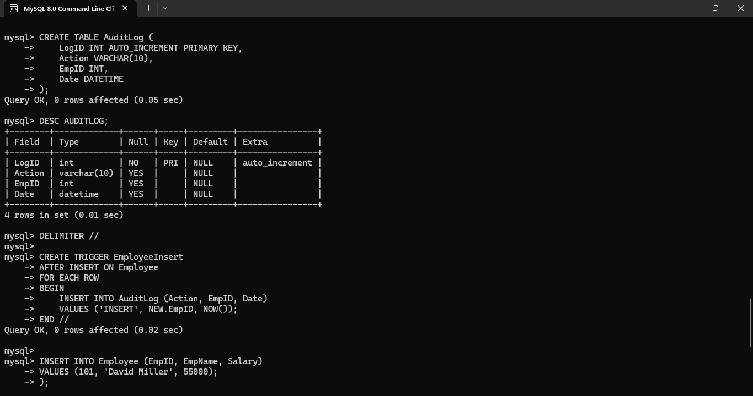

**EX. No. 20 – MySQL String Functions – REPLACE, REPEAT, REVERSE, RIGHT, LEFT, RPAD, LPAD**

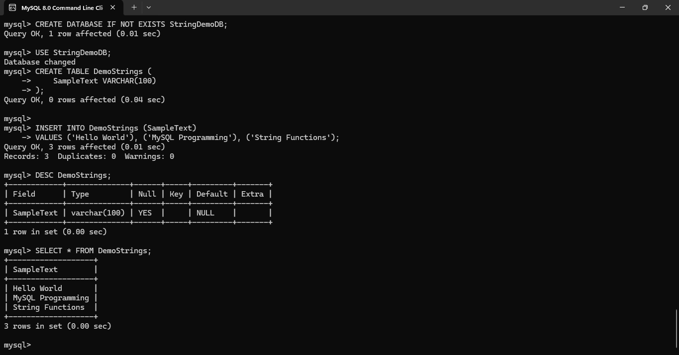

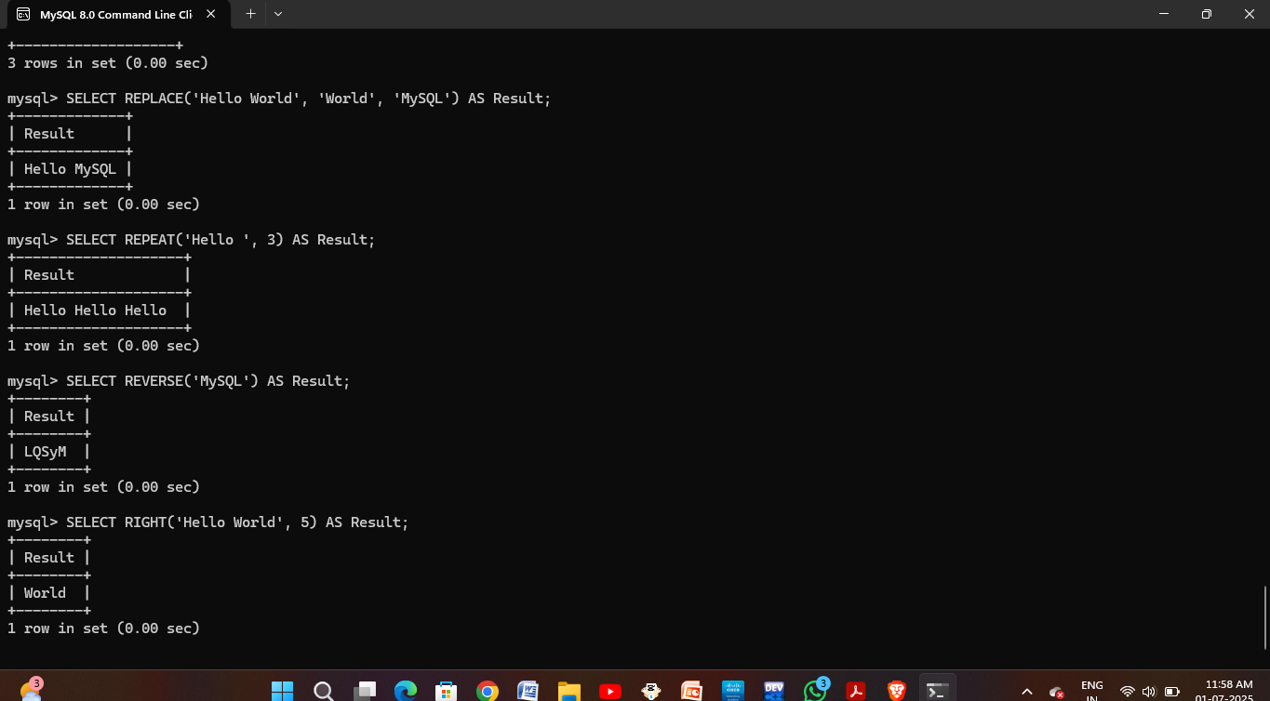

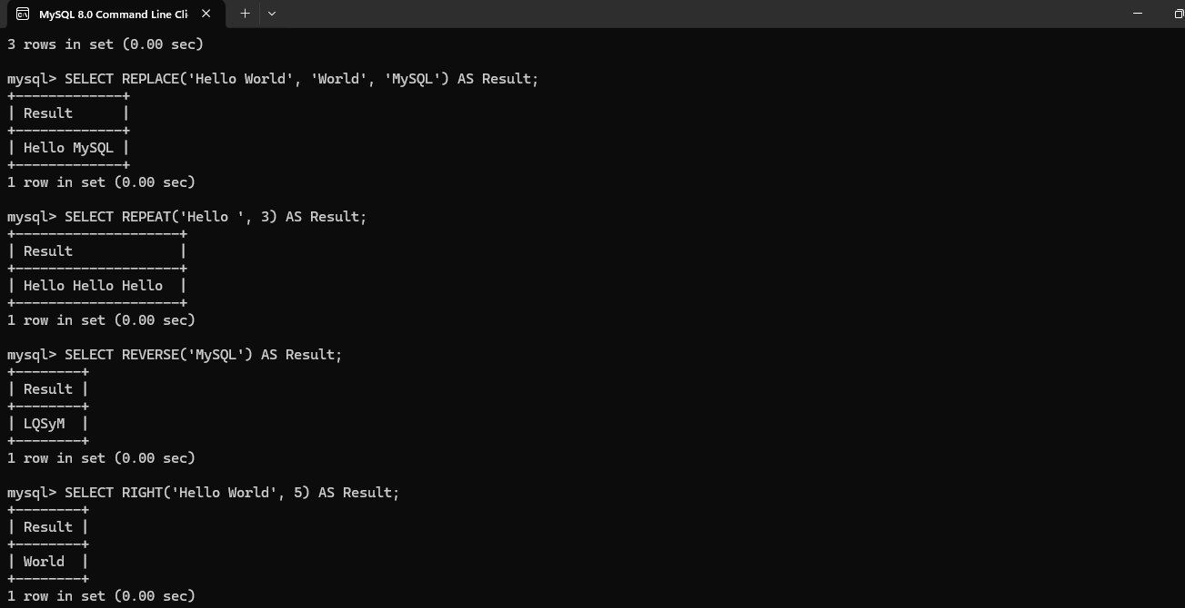

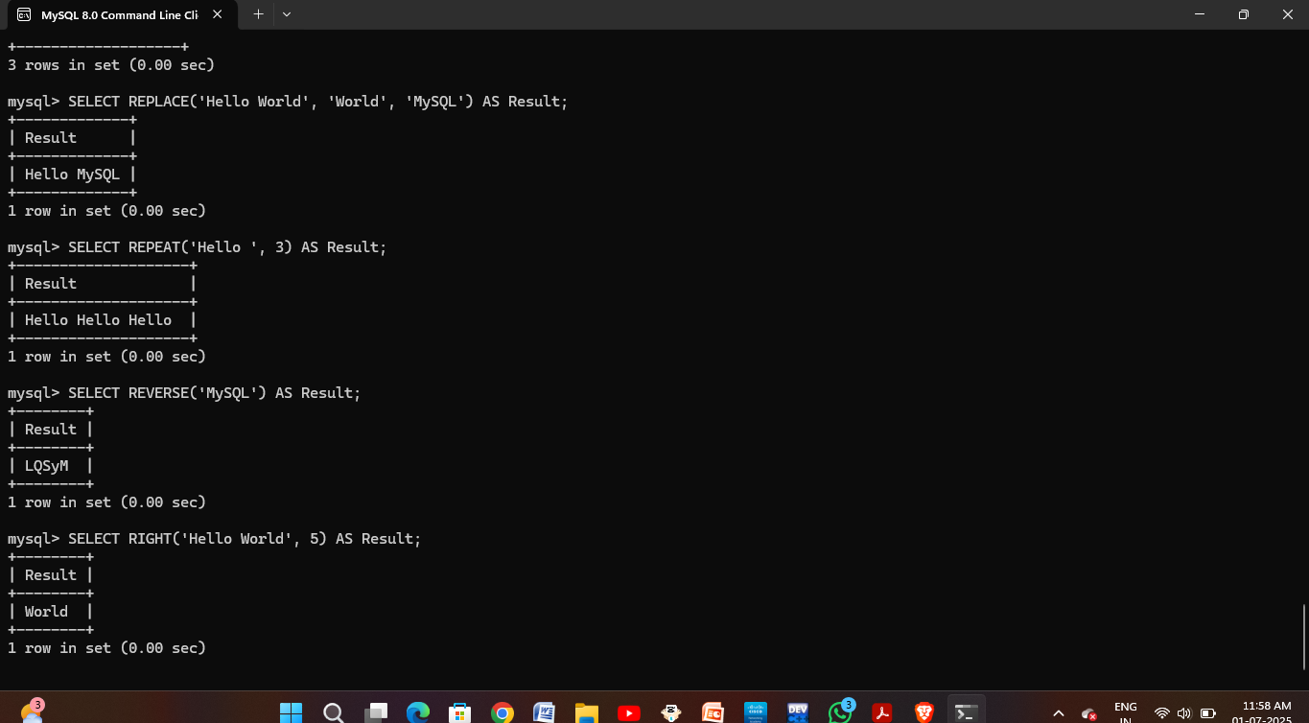

**EX. No. 21 – MySQL String Functions – SPACE, SUBSTR, UPPER, LOWER, TRIM, LENGTH**

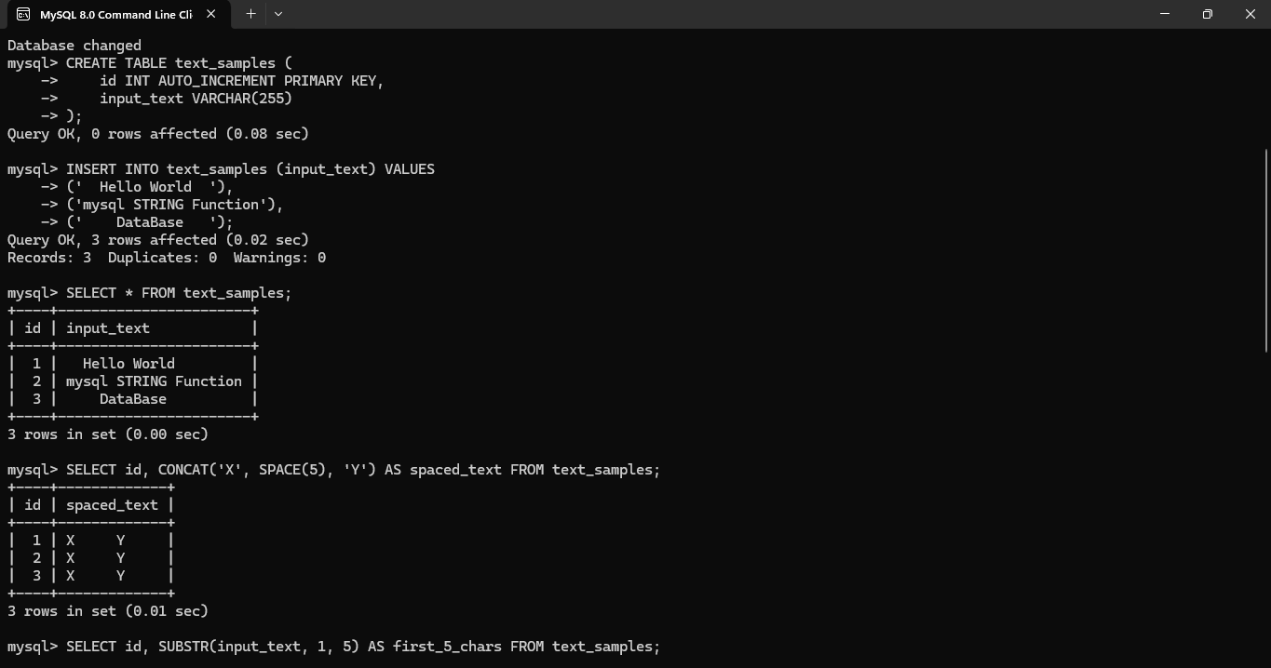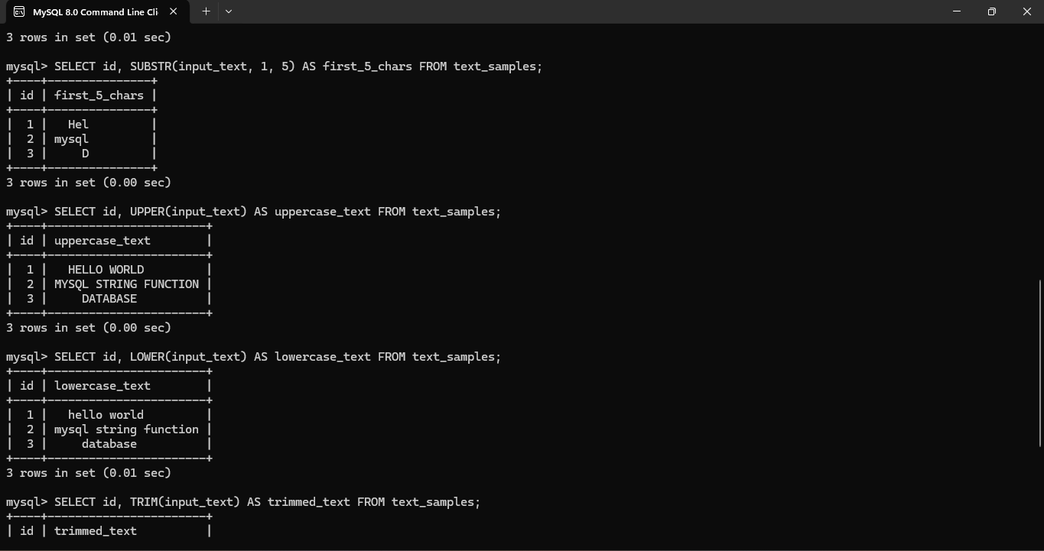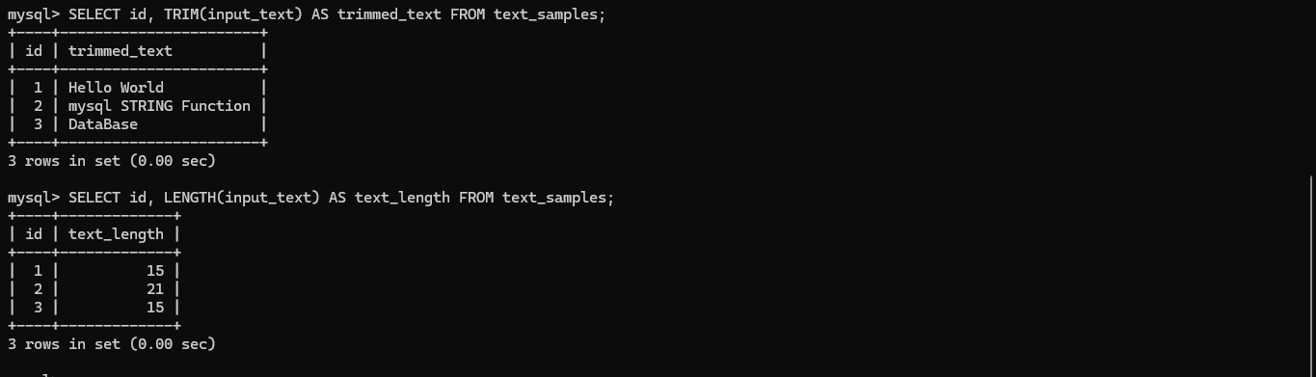

**EX. No. 22 – Database Connectivity Using PHP and MySQL**

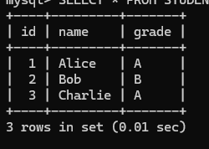

**EX. No. 23 – Case Scenario: MySQL Queries Implementation for Train Ticket Reservation System to**

**Receive Tickets through Social Network**

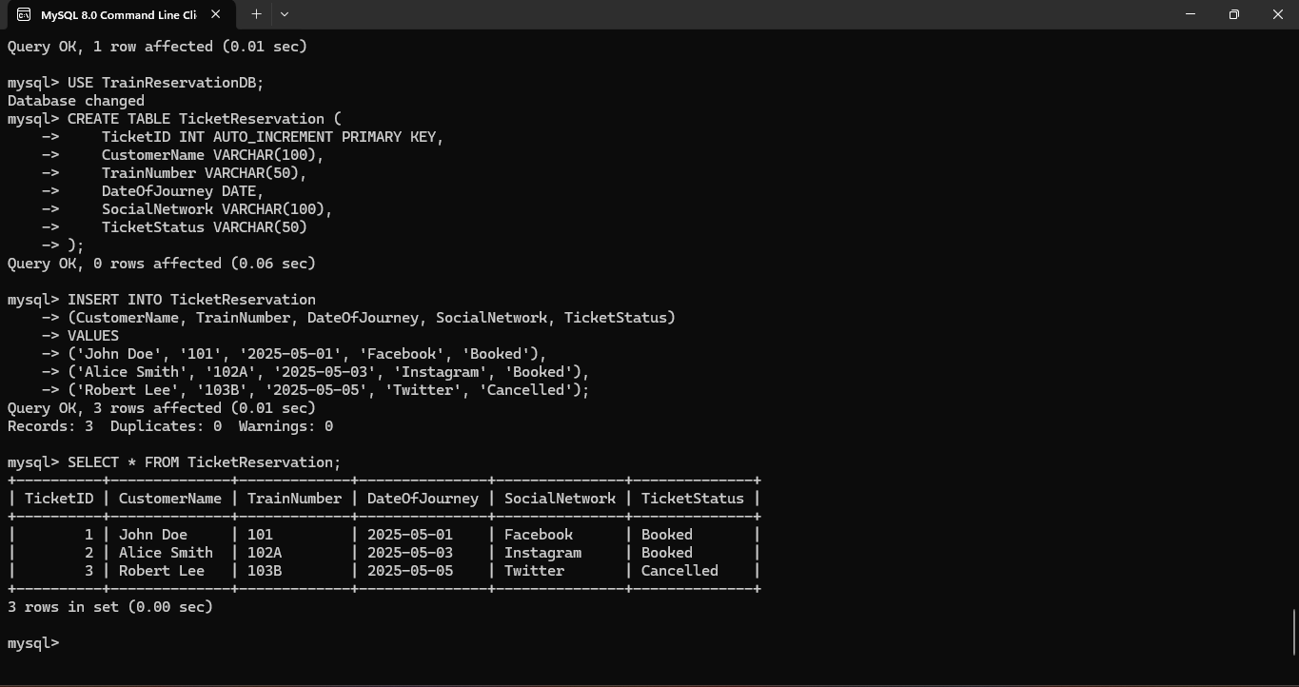

**EX. No. 24 – Case Scenario: MySQL Queries Implementation for College Admission Form**

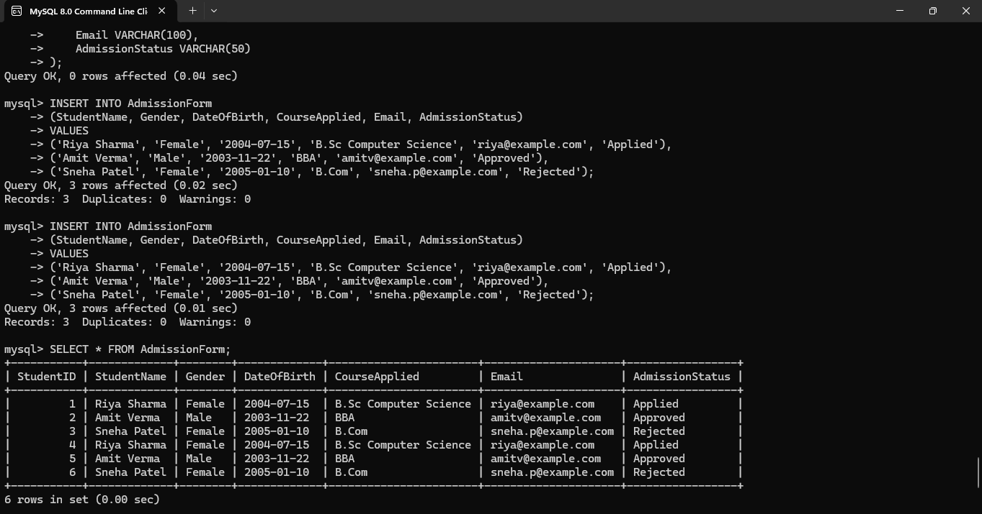

**EX. No. 25 – Case Scenario: MySQL Queries Implementation for QR Enabled Automatic Bus Ticket**

**Booking System**

